5.4.2 Conic Sections (Ellipses)

If a plane passes through a double right circular cone there are four possible resulting curves. These curves are the parabola, circle, ellipse, and hyperbola. These curves are called conic sections and are shown below.
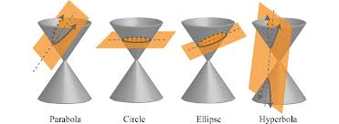

Definition: An ellipse is the set of all points in a plane such that the sum of their distances from two fixed points is constant. Each fixed point is call a focus (plural foci) of the ellipse.

The Equation of an Ellipse: (with a horizontal major axis and center at the origin)
The ellipse with center at the origin and equation

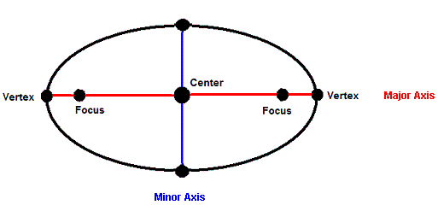
$$(0,0)$$

The Equation of an Ellipse: (with a vertical major axis and center at the origin)
The ellipse with center at the origin and equation

Example 1: Sketch a graph and identify the foci of the ellipse:

Example 2: Sketch a graph and identify the foci of the ellipse:

Example 3: Write the equation of an ellipse with foci and vertices .

Fact: The equation representing a conic that has been shifted units horizontally and units vertically can be formed by replacing and ’s in the original equation with and replacing any ’s in the original equation with .

Example 4: Sketch a graph and identify the foci of the ellipse:

The Circle

Definition: A circle is a set of all points in a plane such that their distance from a point is constant.

Equation for a Circle
The standard equation of a circle with center and radius r is

Note: By dividing both sides of this equation by we obtain . So clearly a circle is an ellipse with major and minor axes of the same length.

Example 5: Write the equation of a circle that has center and passes through the point .

Example 6: Determine the center and radius and sketch a graph of the circle given by the equation:

